Longlevens Code Club

Understanding Functions and Libraries

In this exercise we are going to learn all about functions and libraries so that we can begin to reuse all code you’ve been typing.

Functions are block of code you write which can be reused again and again.

Libraries ( also known as modules ) are files where you keep collection of functions ( such as game function, internet functions and so on. )

Create a new file call mylibs.py

Add the following code.

def area( width, height):
print( width * height )

area(7, 5 )

Run the code

Great. You’ve created a function that prints an area of a rectangle.

All this function can do is print the answer. So let’s make it more flexible.

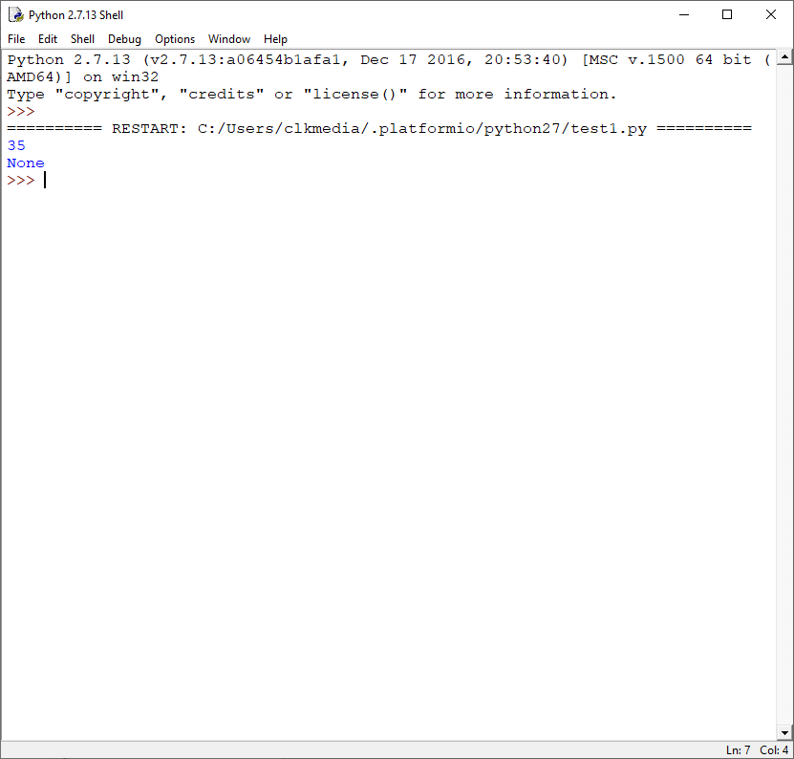
We want to be able to write..

print( area(5,7))

in our programs

So change your code adding the print statement around the area line and run it.

See you get the result we expected and the word None.

This is not quite what we wanted. The print statement is now running twice. Once in the program and once in the function.

Change your code to:

def area( width, height):
return( width * height )

#code to test functions
print(area(7, 5 ))

Ok. As you can see the return command sends the value back to the part of the program that ‘called’ it.

Can you add another function to find the volume of a cube or cuboid?

Think about it for a minute before moving on.
Your program should look something like this.

def area( width, height):
return( width * height )

def volume( width, height, depth ):
return ( width * height * depth )

#code to test functions
print(area(7, 5 ))
print( volume(7,5,10))

When you run it you get the following:

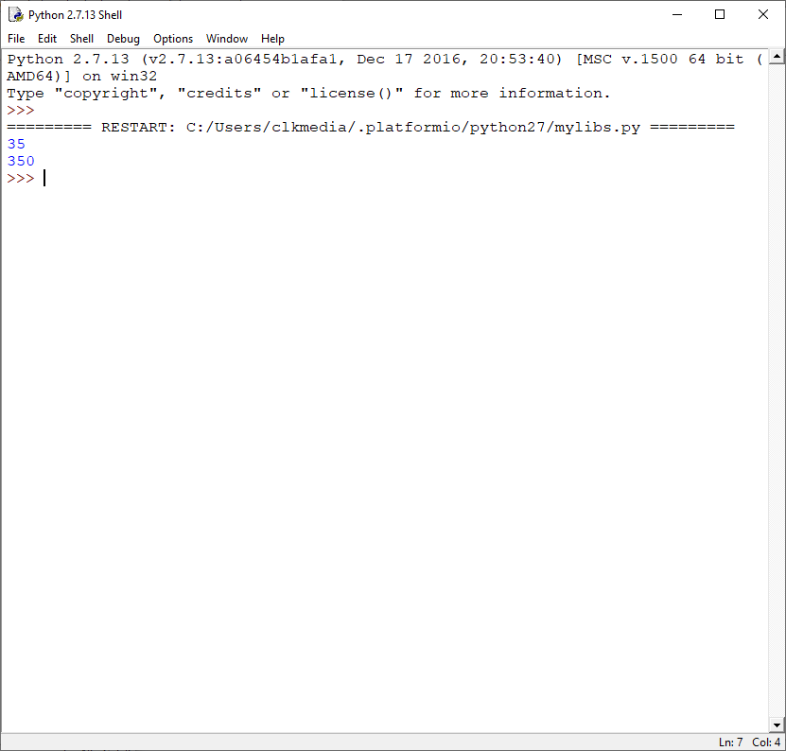

You can even add code to ask for the sizes

width = int(input("Enter width: "))
height = int(input("Enter height: "))
depth = int(input("Enter depth: "))

print( area(width,height))
print( volume(width,height,depth))
Ok. Now we are going to do someting really cool!

Create a new file called test1.py and add the following line

import mylibs

Run it.

Can you see what's happened? Your new program has 'loaded' all the code from your 'mylibs.py' file and executed the code.

The only problem we have now is that we are also running our 'test' code from inside 'mylibs.py'.

So let's fix that.

Open 'mylibs.py' and change code to:

def area( width, height):
return( width * height )

def volume( width, height, depth ):
return ( width * height * depth )

#code to test functions
width = int(input("Enter width: "))
height = int(input("Enter height: "))
depth = int(input("Enter depth: "))
print(__name__)
print( area(width, height ))
print( volume(width,height,depth))
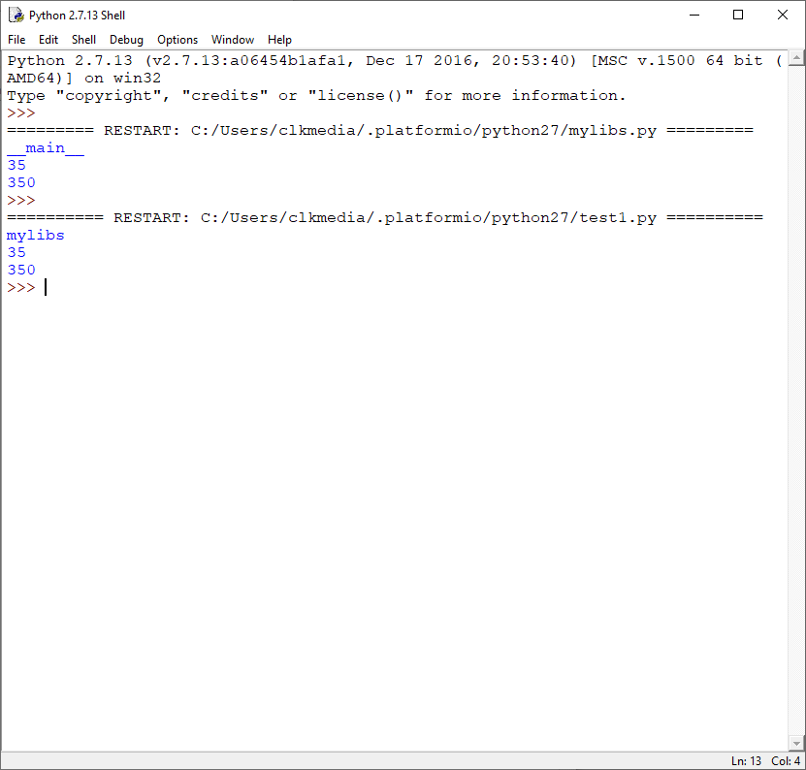
Run both programs to see the difference.

Can you see that the name of the program has changed?

__name__ is a special python variable!

We can use this to ensure that we only run our test code when we want to.

Modify 'mylibs.py' as follows:

def area( width, height):
return( width * height )

def volume( width, height, depth ):
return ( width * height * depth )

#code to test functions
if __name__ == "__main__":
width = int(input("Enter width: "))
height = int(input("Enter height: "))
depth = int(input("Enter depth: "))

print(__name__)
print( area(7, 5 ))
print( volume(7,5,10))

Now run both programs again to see the results. The code in test1 isn't quite right..

So now we need to modify our test1.py to use our library and print out the results.

#import my library code and refer to it as 'myl'
import mylibs as myl

print (myl.area(10,5))
print (myl.volume(10,10,10))

print (myl.area(4,4))
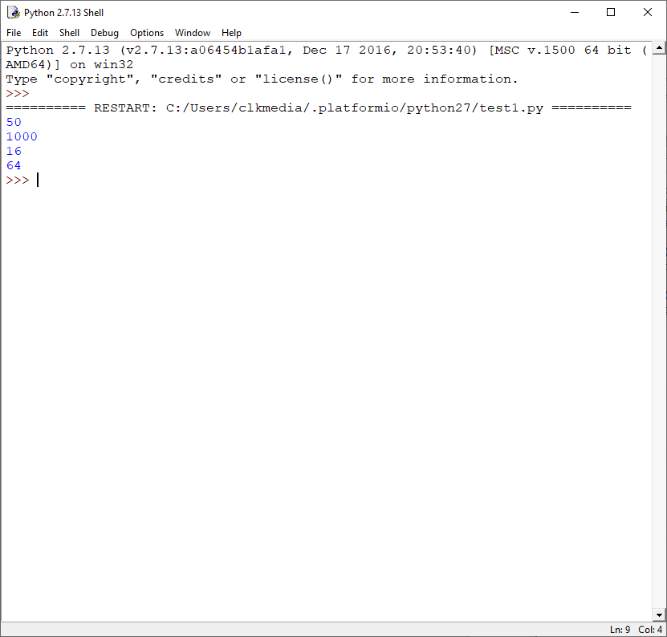
print (myl.volume(4,4,4))

You should get....

Congratulations. You're nearly finished.

Now add more functions to 'mylibs.py' ( including test code ) for:

Area of a circle

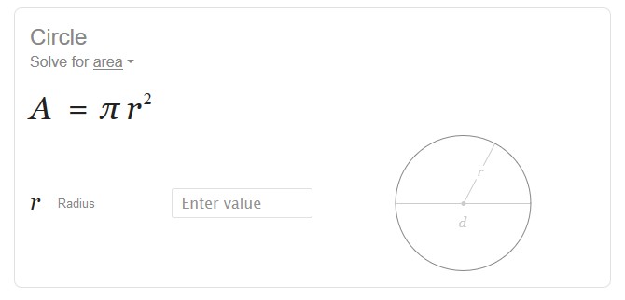

Circumference of a circle

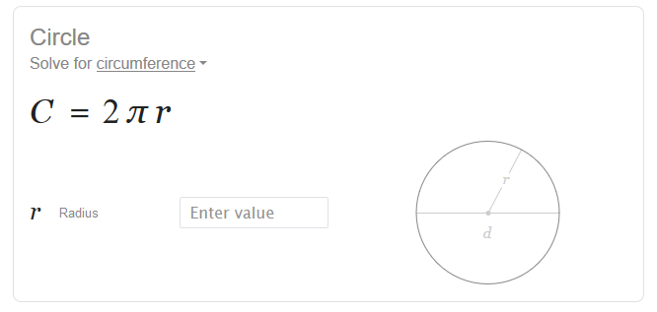
Hint: To use П you will need to import the math library and use math.pi

import math

#code to test functions
if __name__ == "__main__":
print(math.pi)

Area of a triangle:

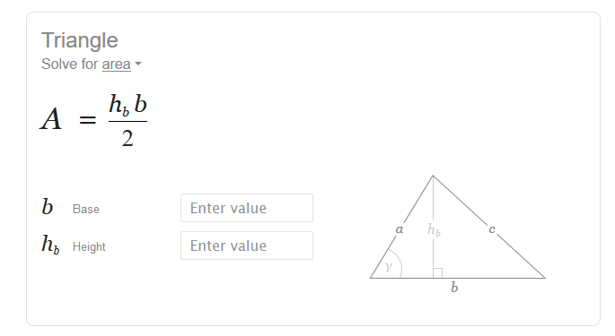
Pythagoras theorem
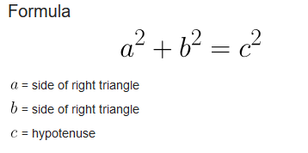

Newton's law of attraction

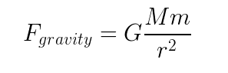
M = mass of object1
m = mass of object2
r = distance between objects
G = gravitational constant
( just set it to 1 for now )

What other formulas can you add....???

Write them down below and see if you can add them to your mylibs.py file.

